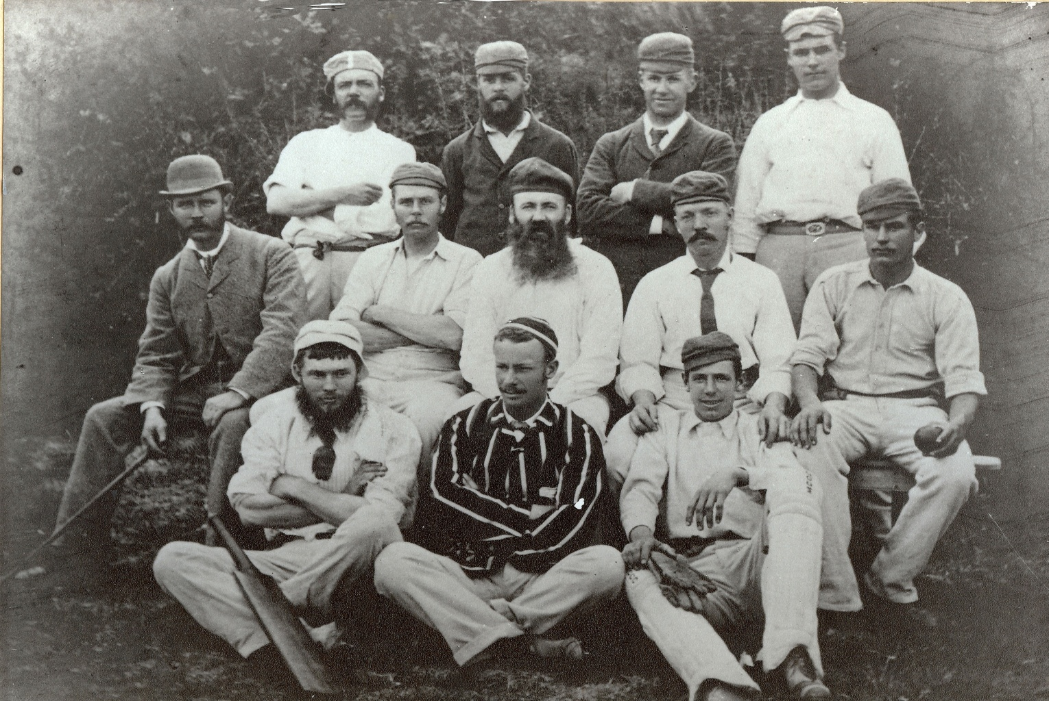

**Canterbury versus Otago 24 February 1881 Hagley Oval**

**Canterbury won by an innings and 232 runs with Watson scoring 175, the first century made in New Zealand**

**Back row: ETA Fuller, EJ Cotterill, JF Hartland, C Frith**

**Middle row: MJ Godby, E Fowler captain, DA Ashby, W Frith**

**Front row: G Watson, AT Redmayne, JN Fowke**